LEADW SE

People. Organisations.Technology

Company

Profile

## For Consultancy, Training and

Capacity Building

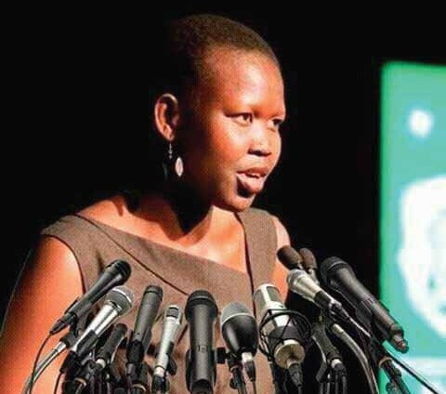

People. Organisations.Technology

MESSAGE FROM THE CEO 2

**CONTENTS**

About Us 3

Vision 3

Mission 3

Core value 3

Leadwise Management Structure 4

Leadwise Enterprise Governance 4

HIGHLIGHTS OF SUCCESSFULLY COMPLETED PROJECTS

Administratve Skills Training 5

Women and Youth Leadership Programme (2024–2025) 5

Road Safety and Traffic Management Project 5

Food Security and Livelihood Needs Assessments 5

Market Assessment, Gender Analysis, and Food Security Baseline 5 WASH Baseline Survey 5

Baseline Health Surveys 5

National Education Assessment 5

HR and Institutional Capacity Building Program 5

Peace and Reconciliation Program 6

Project Evaluation Services 6

Child Protection and Safety Capacity Building 6

Health WASH Assessment and Community Training 6

KEY CONSULTANCY AND TRAINING PROGRAMS

Governance and Public Sector Reform 6

Leadership, Management, and Organizational Development 6 Gender Equality and Social Inclusion 7

Economic Empowerment and Private Sector Development 7

Humanitarian Response and Resilience Building 7

Child Protection and Social Welfare 7

Health, Nutrition, and WASH 7

Education and Skills Development 7

Climate Change, Environment, and Natural Resources 7

Monitoring, Evaluation, Accountability, and Learning (MEAL) 7 Communication, Advocacy, and Strategic Engagement 7

WORKSHOPS/SEMINARS

Leadership and Executive Management 8

Project and Program Management 8

Governance, Accountability, and Policy 8

Gender, Inclusion, and Human Rights 8

Humanitarian and Resilience Programming 8

Monitoring, Evaluation, Accountability and Learning (MEAL) 8

Communication, Advocacy, and Stakeholder Engagement 8

Organizational Development and Change 8

Economic Empowerment and Livelihoods 9

Climate Action and Sustainable Development 9

Information Technology and Cybersecurity Seminars 9

Information Security Governance and Risk Management 9

Digital Transformation and IT Strategy for Development

Organizations 9

Secure Data Management and Digital Privacy 9

ICT4D (Information and Communication Technologies for Development)

PROJECT HIGHLIGHTS - PHOTO GALLERY 10

SUPPLIES 12

**LEADWISE**

01

### Message from the CEO

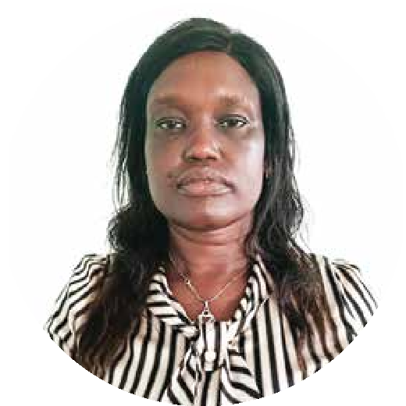

### ADVANCING TALENT. ACCELERATING IMPACT.

At Leadwise, we believe that investing in people is the most powerful way to transform institutions, systems, and societies. Our mission is to accelerate impact by equipping individuals, teams, and organi- zations with the knowledge, skills, and tools needed to lead effectively in South Sudan’s complex devel- opment landscape.

Through tailored consultancy and capacity-building solutions, we align with national priorities and work in close partnership with UN agencies, development partners, and public and private sector actors. From governance and peacebuilding to education, gender equality, climate resilience, and innovation, we are committed to delivering results that are locally grounded and globally informed.

Our experienced team stands ready to support your goals whether advancing institutional reform, building technical capacity, or empowering the next generation of leaders. Together, we can create lasting change.

Partner with Leadwise to strengthen systems, empower people, and transform your impact.

**Transform with Leadwise.**

Warm regards,

**Grace Arach Deng**

Chief Executive Officer

*Leadwise Consultancy and Training*

02

**LEADWISE**

###### About Leadwise

Leadwise is a professional consultancy firm established in 2012 and duly registered in both Australia **(ABN: 64803078970)** and South Sudan (Registration No. 35957). We are a diverse team of experts with cross-sectoral experience, committed to equipping leaders in the Public, Private, NGOs, Development Agencies, civil society sectors with practical skills and strategic tools to enhance institutional effectiveness and impact.

We support organizations to strengthen performance, solve complex challenges, and implement tailored solutions that drive efficiency, profitability, and sustainable growth. Our work spans across business man- agement, strategic planning, leadership development, and organizational transformation ensuring our clients are equipped to thrive in dynamic environments.

###### Vision

To be a catalyst for innovative change and continuous improvement empowering people, strengthening human resource capacity, and building high-performing organizations and resilient institutions for sustainable impact.

###### Mission

To inspire, empower, and support leaders across business, government, and civil society to drive transfor- mative change. We work to align strategy, people, culture, structure, and systems to ensure organizations achieve their goals effectively and sustainably.

###### Our Core Values

At Leadwise, our work is guided by values we deeply believe in and consistently uphold:

* **Integrity and Professionalism**: We maintain the highest standards of ethics, accountability, and professional conduct in everything we do.
* **Client Commitment and Partnership:** We are dedicated to building strong, collaborative relation ships with our clients, grounded in trust, respect, and shared success.
* **Continuous Improvement and Transformation:** We strive for excellence through ongoing learning, innovation, and the pursuit of meaningful change.

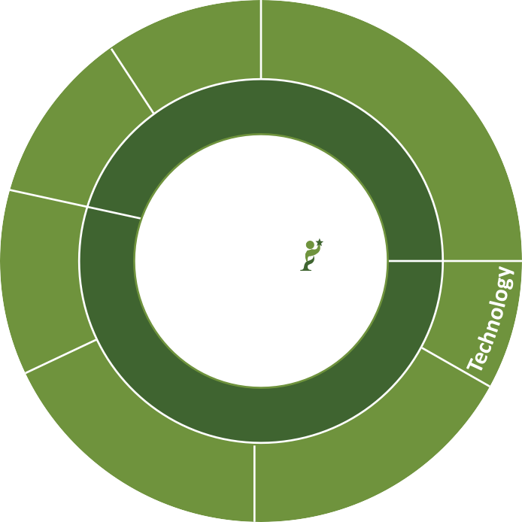

LEADW SE

People. Organisations.Technology

**CEO**

**Auditor**

**Legal Advisor**

**Training & Partners & Capacity Building Project Manager**

**Business Development Manager**

**Admin & Finance Manager**

**Research & Innovation Manager**

**M & E**

**Training Seminars Workshops**

**Senior Consultant**

**Marketing & Client Engagement**

**Management**

**& Operations**

**Research & Development Services**

**Assessments & Feedback**

**Mentoring & Coaching**

**Consultants**

**Business Engagement & Support**

**HR**

**Accountant**

**Partnerships Innovation & Knowledge Mobilization**

**Check-ins &**

**Reflections**

**Associate Consultants**

**Media Engagement**

**Logistics &**

**IT Support**

**Strategic Research Initiatives & Performance**

# LEADWISE ENTERPRISE GOVERNANCE

**LEADWISE MANAGEMENT STRUCTURE**

Leadwise is led by a dynamic, award-winning MBA professional and supported by a multidisciplinary team of seasoned experts, including educators, public administrators, researchers, transport and agricultural engineers, and ICT practitioners. Together, the leadership team shares a strong commitment to transfor- mational leadership and a common goal: to empower change agents and promote sustainable develop- ment.

Our governance approach is informed by diverse professional experiences across South Sudan, Australia, the United Kingdom, the United States, Canada, Kenya, Uganda, and Rwanda. This international exposure strengthens our ability to deliver globally informed yet locally grounded solutions.

Leadwise operations are underpinned by a robust governance framework and adherence to international best practices. Our institutional policies include:

Protection from Sexual Exploitation and Abuse (PSEA) Policy

* Environmental Policy

Gender Equality and GBV Code of Conduct

* Health and Safety Policy
* Anti-Bribery and Corruption Policy Conflict of Interest Policy

Child Protection Policy

Monitoring and Evaluation (M&E) Policy

* Procurement Policy
* Human Resources and Finance Policies
* Organizational Code of Conduct
* Board of Directors Oversight Procedures

These policies ensure integrity, accountability, transparency, and ethical conduct in all aspects of our work and partnerships.

#### HIGHLIGHTS OF SUCCESSFULLY COMPLETED PROJECTS

|  |  |
| --- | --- |
| **Women and Youth Leadership Programme (2024–2025)** | *Partner: UNDP, Office of the Vice President (Chair of Gender and Youth Cluster)*  A one-year leadership and internship program for 200 participants focused on capacity building, mentorship, and preparing youth especially women for leadership roles and employment across South Sudan. |
| **Road Safety and Traffic**  **Management Project** | *Partners: University of Juba, JICA (2022–2024)*  Designed and implemented a road safety and traffic management initiative targeting drivers and pedestrians. Trained 500 drivers in defensive driving and reached 10,000 residents through safety awareness campaigns. |
| **Food Security and Livelihood Needs Assessments** | *Partner: Relief International (2024)*  Conducted multi-county assessments in Maban, Longechuk, and Melut to identify food security gaps, resilience needs, and livelihood opportunities, informing community-based interventions. |
| **Market Assessment, Gender Analysis, and Food Security Baseline** | *Partner: USAID/RASS Activity (2022)*  Undertook assessments across 13 counties and 5 states, producing actionable insights on market systems, gender dynamics, and agricultural resilience. |
| **WASH Baseline Survey** | *Partner: DT Global (2022)*  Assessed water access and hygiene practices in Duk, Pibor, and Uror counties, generating data that guided WASH interventions and infrastructure investment. |
| **Baseline Health Surveys** | *Partners: South Sudan Red Cross (Ikotos, 2020), Amref Health Africa (Maridi & Ibba, 2021)*  Evaluated maternal and child health, nutrition, and service coverage to inform community health strategies and programming. |
| **National Education**  **Assessment** | *Partners: UNESCO (2023)*  Supported the Humanitarian Needs Overview by assessing dispari- ties in education access, infrastructure, and policy implementation. |
| **HR and Institutional Capacity Building Program** | *Partner: UNDP (4.5 Years), CSF (2019-2022)*  Delivered human resources and institutional strengthening programs across 68 ministries/agencies of the Government of South Sudan. |

|  |  |
| --- | --- |
| **Peace and Reconciliation**  **Program** | *Partner: Peace Canal (June–August 2023)*  Facilitated community-driven peacebuilding efforts in Jonglei and Lakes State through participatory dialogue and local leadership empowerment. |
| **Project Evaluation Services** | *Partners: UN Women, Jonglei Civil Society Network, ZOA, CSF (2020–2023)*  Conducted multiple mid-terms and endline evaluations to assess impact, draw lessons learned, and enhance accountability for peacebuilding, women’s empowerment, and WASH interventions. |
| **Child Protection and Safety Capacity Building** | *Partners: Ministry of Gender, Child, and Social Welfare – Jonglei State, UNMISS, UNHCR (2021–2022)*  Trained 240 children and multiple child protection actors; established local protection committees and strengthened referral systems for abuse prevention and child safeguarding. |
| **Health WASH Assessment and Community Training** | *Partners: WHO, UNICEF, Life of Service Foundation, Ministry of Health (June–Dec 2023)*  Conducted WASH assessments and training in Bor, Duk, Twic East, and Akobo counties, focusing on hygiene promotion, water safety, and healthcare-associated infection prevention. |

### KEY CONSULTANCY AND TRAINING PROGRAMS

Outlined below are core consultancy and training programs designed to support corpo- rate clients, UN agencies, and development partners in achieving their strategic and development objectives.

1. **Governance and Public Sector Reform**

 Public administration and civil service reform

 Strategic planning and policy development

 Results-based management (RBM)

 Anti-corruption, transparency, and accountability

 Decentralization and local governance

 Regulatory and legal frameworks

1. Leadership, Management, and Organizational Development

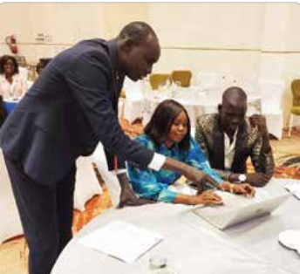

 Executive and public sector leadership training

 Change management and institutional transformation

 Organizational capacity and needs assessments (OCA/ONA)

 Performance management systems

 Team dynamics and organizational culture

 Coaching and mentorship programs

1. Gender Equality and Social Inclusion

 Gender mainstreaming and gender audits

 Gender-responsive budgeting

 Women’s leadership and political participation

 Disability inclusion and inclusive development

 Protection from gender-based violence (GBV)

1. Economic Empowerment and

**Private Sector Development**

* + MSME and entrepreneurship development
  + Value chain analysis and market systems development
  + Cooperative development and financial literacy
  + Youth and women economic inclusion
  + Public-private partnership (PPP) frameworks

1. Humanitarian Response and Resilience Building
   * Emergency preparedness and
   * response planning
   * Conflict sensitivity and “Do No Harm” approaches
   * Humanitarian needs assessments
   * Crisis recovery and livelihoods support
   * Disaster risk reduction (DRR) and resilience
2. Child Protection and Social Welfare
   * Child rights and protection systems
   * strengthening
   * Case management and referral pathways
   * Safeguarding standards and compliance
   * Social protection and child welfare programs
   * Training for teachers, social workers, and CP actors
3. Health, Nutrition, and WASH
   * Health system strengthening
   * Community health and social behavior change (SBC)
   * Nutrition-sensitive programming
   * Water, sanitation, and hygiene promotion
   * Mental health and psychosocial support (MHPSS)
4. Education and Skills Development
   * Education in emergencies (EiE)
   * Curriculum development and teacher training
   * Early childhood development (ECD)
   * Technical and vocational education and training (TVET)
   * Inclusive education and disability mainstreaming
5. Climate Change, Environment, and

**Natural Resources**

* + Climate adaptation and mitigation strategies
  + Environmental impact assessments (EIA)
  + Natural resource management
* Green economy and sustainable livelihoods
* Climate financing and carbon accounting

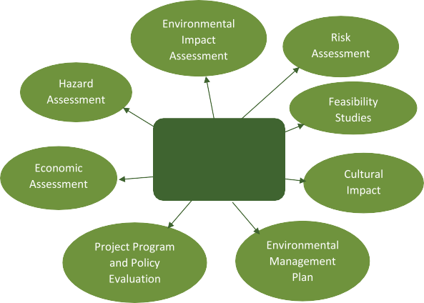

**LEADWISE SOCIAL IMPACT ASSESSMENT**

1. Monitoring, Evaluation,

**Accountability, and Learning (MEAL)**

* + Baseline, midline, and endline evaluations
  + Impact assessment and performance reviews
  + Theory of Change and logical framework development
  + Data collection tools and methods
  + Knowledge management and learning systems

1. Communication, Advocacy, and

**Strategic Engagement**

* + Strategic communication and media engagement
  + Advocacy strategy development
  + Social and behavior change
  + communication (SBCC)
  + Stakeholder mapping and engagement
  + Policy influencing and coalition-building

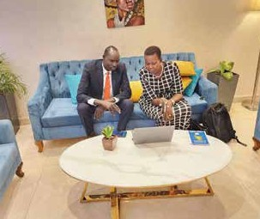

*Apply industry-best practice in developing a business case that explains your rationale to senior leaders and stakeholders.*

### WORKSHOPS/SEMINARS

key seminars offerings tailored for corporate clients, UN agencies, and development part- ners. Each is strategically designed to enhance institutional capacity, cultivate effective leadership, and drive sustainable development outcomes.

1. Leadership and Executive Management

 Transformational Leadership for Impact

 Ethical Leadership and Integrity in Public Service

 Strategic Thinking and Decision-Making for Executives

 Leading Organizational Change and Innovation

 Women in Leadership and Executive Presence

1. Project and Program Management

 Results-Based Management (RBM) and Logical Frameworks

 Project Cycle Management in Development Contexts

 Agile and Adaptive Program Management Risk Management and Contingency Planning Donor Compliance and Grant Management



1. Governance, Accountability, and Policy

 Good Governance, Rule of Law, and Anti-Corruption

 Policy Analysis, Formulation, and Advocacy

 Public Financial Management and Budgeting

 Accountability and Transparency -

 Mechanisms in Institutions

 Decentralization and Local Governance Systems.

1. Gender, Inclusion, and Human Rights

 Gender Mainstreaming in Development and Humanitarian Action

 Building Inclusive Institutions and Disability Mainstreaming

 Gender-Based Violence (GBV) Prevention and Response

 Human Rights-Based Approaches to Programming

 Safeguarding and Protection in Development Work

1. Humanitarian and Resilience Programming

 Humanitarian Principles and Standards (Sphere, CHS)

 Conflict Sensitivity and Do No Harm

 Emergency Response Planning and Coordination

 Building Community Resilience and Early Recovery

 Climate Resilience and Disaster

 Risk Reduction (DRR)

1. Monitoring, Evaluation, Accountability

**and Learning (MEAL)**

 Designing MEAL Systems for Impact

 Data Collection Tools and Digital Platforms

 Theory of Change and Impact Measurement

 Qualitative and Quantitative Evaluation Methods

 Learning and Knowledge Management for Development

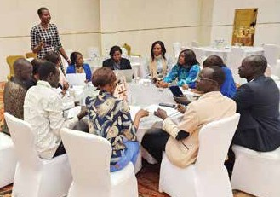

1. Communication, Advocacy, and

**Stakeholder Engagement**

 Strategic Communication and Branding for Impact

 Advocacy Strategy Design and Implementation

 Media Relations and Crisis Communication

 Stakeholder Mapping and Influence Strategies

 Behavior Change Communication (BCC/SBCC)

1. Organizational Development and

**Change**

 Organizational Capacity and Needs

 Assessment (OCA/ONA)

 Team Building, Conflict Resolution, and Group Dynamics

 Performance Management and Accountability Systems

 Workplace Culture, Diversity, and Inclusion Leading Through Institutional Change

1. Economic Empowerment and

**Livelihoods**

* + Entrepreneurship and Innovation for Development
  + Cooperative and MSME Development
  + Market Systems and Value Chain Analysis
  + Financial Literacy and Business Planning
  + Youth and Women’s Economic Empowerment

1. Climate Action and Sustainable Development
   * Climate Policy and Environmental Governance
   * Sustainable Resource Management
   * Green Economy and Climate Financing
   * Integrating Climate Change in Development Programming
   * Climate Justice and Community Adaptation Strategies
2. Information Technology and

**Cybersecurity Seminars**

As digital systems become central to organizational operations and service delivery, building capacity in information technology and cybersecurity is essen- tial for resilience, compliance, and innovation. These seminars equip participants with the technical knowledge and strategic insight needed to manage digital transformation, safeguard data, and ensure operational continuity.

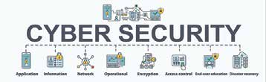

1. Cybersecurity Fundamentals for Non-Technical Professionals

 Understanding cyber threats and risks

 Data protection and privacy compliance (e.g., GDPR, national laws)

 Safe digital communication and secure document sharing

 Phishing, malware, and ransomware awareness

 Building a cyber-aware organizational culture

1. Information Security Governance and Risk

**Management**

 Developing and implementing cybersecurity policies

 Risk assessment frameworks and mitigation strategies

 Incident response planning and disaster recovery

 Cyber insurance and organizational liability

 Aligning with ISO/IEC 27001 standards

1. Digital Transformation and IT Strategy for Development Organizations

 Leveraging technology for efficiency and impact

 Cloud computing, data integration, and system interoperability

 Digital tools for monitoring, evaluation, and reporting

 Cyber-ethics and responsible tech use

IT procurement and vendor management

1. Secure Data Management and Digital

**Privacy**

 Data classification, storage, and access control

 Encryption, backup, and secure file transfer protocols

 Privacy-by-design in digital service delivery

 Legal and ethical considerations in data handling

 Building data protection frameworks for humanitarian settings

1. ICT4D (Information and Communication Technologies for Development)
   * Using mobile technology for development outreach
   * Digital inclusion and bridging the technology gap
   * Blockchain for transparent aid distribution
   * GIS and remote sensing for planning and evaluation
   * E-learning and virtual collaboration platforms

### PROJECT HIGHLIGHTS - PHOTO GALLERY

*Women and Youth Leadership Programme*

*Role and Responsibilities of the Undersecretaries and the Ministers*

*Strategic Planning State Ministers*

*Women and Youth Leadership*

*Leadership and Management in Public Sector, Director Generals*

*Youth Employability, Entrepreneurship and Livelihoods Opportunities Workshop*

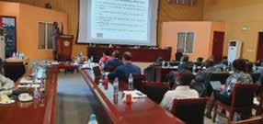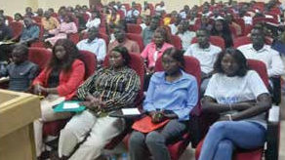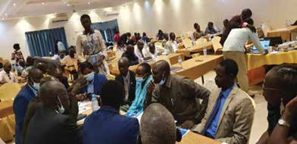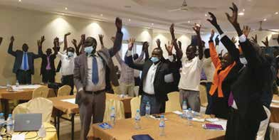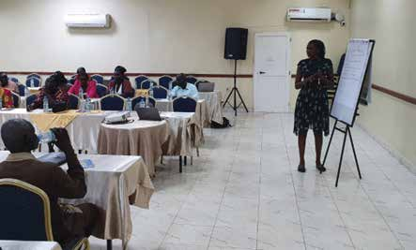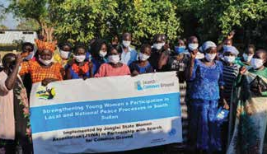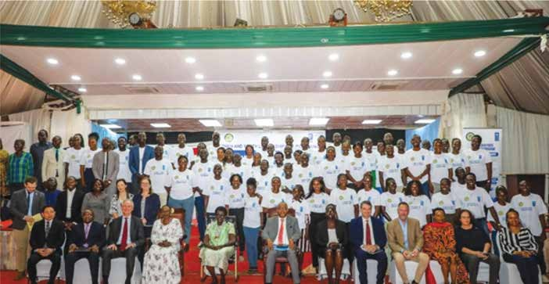

*Local Peace Process*

### LEADWISE 10

*Gender Mainstreaming in Public Sector*

*Leadership and Executive Management Gender Equality and Social Inclusion Governance, Accountability, and Policy*

*Entrepreneurship and Innovation for Development*

*Women in Public Administration and Management*

*Foresight Planning Workshop, Trainer of Trainers Preparing Today for the Uncertainties of Tomorrow*

*Peace and Reconciliation, Ayod, Gender Equality and Social Inclusion Entrepreneurship and Innovation for Development*

*Youth Leadership and Mentoring Program, Building Community Resilience and Early Recovery*

*Communication, Advocacy, and Stakeholder Engagement*

*Undersecretaries*

***Topics:*** *Public Financial Management and Budgeting Project and Program Management*

*Governance, Accountability, and Policy*

**LEADWISE** 11

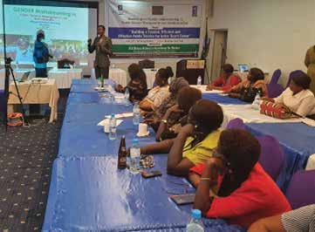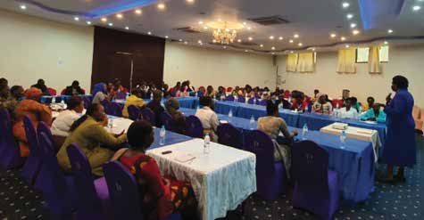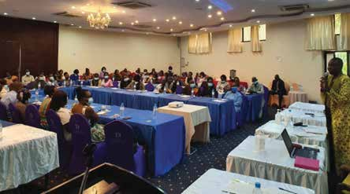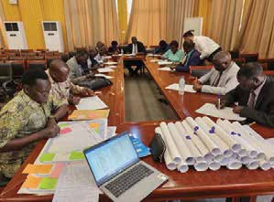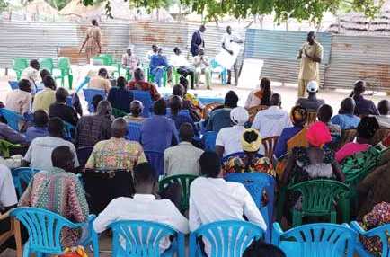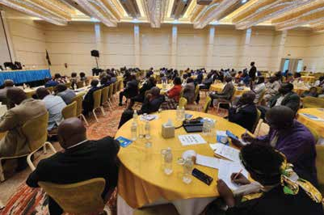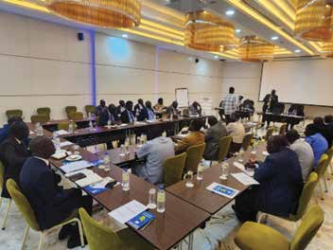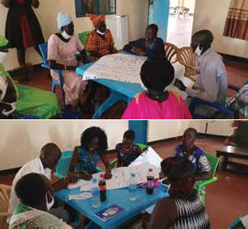

# SUPPLIES

We deliver high-quality, essential supplies including food, medical kits, WASH items, shelter materials, ICT,

furniture, and stationery to support humanitarian relief, community programs, and development projects in partnership with UN agencies, NGOs, and governments.

|  |  |
| --- | --- |
| **Category** | **Key Items** |
| **Food & Nutrition** | **RUTF, therapeutic milks, general food rations, micronutrients**   * General food rations (maize, sorghum, pulses, oil) delivered via river barges and airdrops to hunger stricken regions * Therapeutic foods ready-to-use therapeutic food (RUTF) and therapeutic milks for treating severe acute malnutrition among children * Micronutrient supplements including Vitamin A, balanced energy-protein supplements, and deworming tablets distributed through UNICEF-sup- ported nutrition and health programs |
| **Medical Supplies & Healthcare Kits** | **Vaccines, antibiotics, ORS, cholera kits, primary-health backpacks**   * Essential vaccines and routine immunization supply to prevent vaccine-preventable diseases. * Antibiotics (e.g., amoxicillin) and treatments for pneumonia, diarrhea, malaria often pre-packaged in emergency medical kits. * Cholera and WASH kits including rehydration salts, disinfectants, chlorine water-treatment materials, oral rehydration solution (ORS), sanitation supplies * Portable primary-care kits enabling mobile teams (e.g. MSF backpacks) to deliver first-aid, malaria treatment, wound care, nabilization in remote settings. |
| **Water, Sanitation**  **& Hygiene (WASH** | **Jerry cans, water-treatment tablets, hygiene kits, soap**   * Jerry cans, water containers, chlorine tablets for water purification, and aquatabs to ensure safe drinking water in camps or displaced communities * Hygiene kits with soap, sanitary pads, menstrual hygiene items, and basic toiletries essential for maintaining hygiene, especially during displacement |
| **Shelter &**  **Non-Food Items** | **Blankets, mats, mosquito nets, cooking gear, solar lamps**   * Blankets and sleeping mats for protection against cold and nighttime moisture. * Cooking utensils, mosquito nets, sleeping mats, solar lamps, essential non-food items provided to displaced families |

|  |  |
| --- | --- |
| **Category** | **Key Items** |
| **Emergency Infrastructure & Logistics** | **Barge support, airdrops, emergency transport infrastructure**   * Barges and airdrop support: Crucial for delivering supplies especially food and medical kits to inaccessible areas due to roadblocks or seasonal floods * Emergency transport/logistics: Including barge coordination, air transport to bypass conflict-affected zones. |
| **ICT Supplies** | * **Devices:** Laptops, tablets, smartphones, solar chargers * **Connectivity:** VSAT, routers, modems, satellite phones, radios * **Power Backup:** UPS, solar batteries, portable generators * **Storage:** Servers, hard drives, cloud services * **Accessories:** Printers, projectors, webcams, cables * **Software & Security:** Antivirus, firewalls, encrypted USBs * **Kits:** Emergency ICT kits, digital learning kits, field communication kits |
| **Furniture Supplies** | * **Office:** Desks, chairs, filing cabinets, meeting tables, storage units * **Education:** Student desks, teacher chairs, classroom shelves, whiteboards * **Health:** Examination tables, waiting benches, medicine cabinets, bedside lockers * **Field/Community:** Folding tables, plastic chairs, stools, tent kits |
| **Stationery Supplies** | * **Writing tools:** Pens, pencils, markers * **Paper:** A4 sheets, notebooks, flipcharts * **Filing:** Folders, binders, staples * **Desk items:** Staplers, scissors, tape, paper clips * **Presentation:** Whiteboard markers, flipchart stands * **Education:** Exercise books, chalk, crayons, erasers |

**Our Partners**

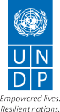Leadwise is to deliver results-based consultancy services, trainings and Capacity buildings. Leadwise has worked with several indigenous and international humanitarian and development organizations to imple- ment demand driven programs in South Sudan and the East African region. Below are some of our major partners for references:





The UN Refugee Agency

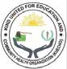



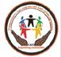cina



**community in need aid**

**from the heart of humanity**

**University of Juba**

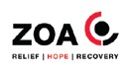

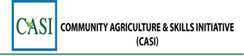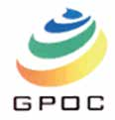

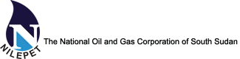

### LEADWISE 14

**Company Certificates**

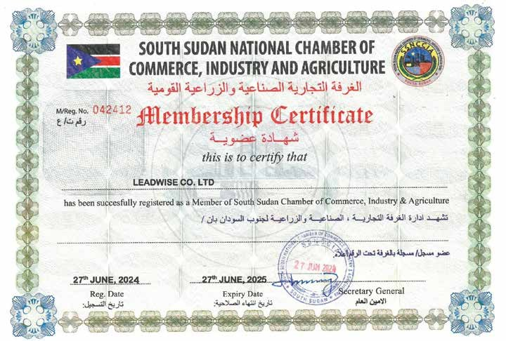

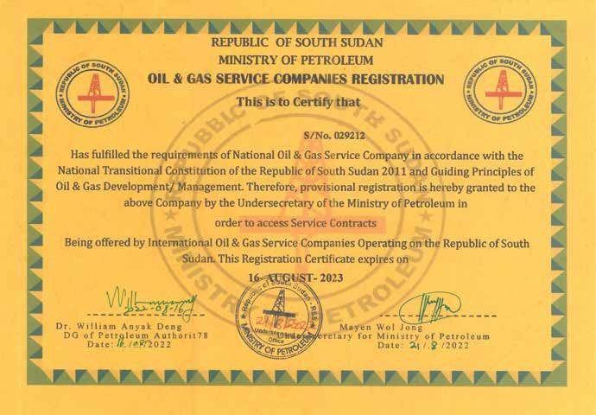

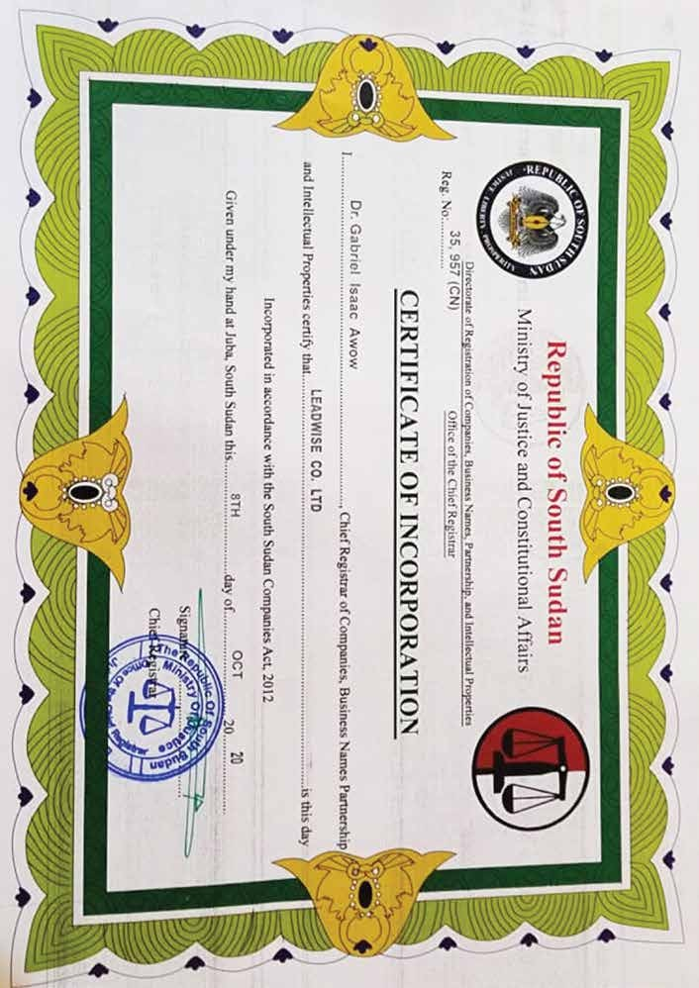



Republic of South Sudan

**NATIONAL REVENUE AUTHORITY**

##### TAX CERTIFICATE

|  |  |  |
| --- | --- | --- |
| Name:  **LEADWISE CO. LTD** | Business Reg. Number:  **35957** | |
| Company Address: |  |  |
| **MUNDIRA NEXT TO ECO BANK, MINISTRIES ROAD, Fl: SECOND FLOOR, Room/Door: 1, MUNDIRA**  **NEXT TO ECO BANK, MINISTRIES** | Registered Address: **Central Equitoria, Juba, South Sudan** | Date of Issue:  **18 Mar 2022** |
| **ROAD** |  |  |

This is to certify that: **LEADWISE CO. LTD** is a registered Taxpayer with the NRA and has been issued a Tax Identification Number as specified under section 17 of the taxation act.

**TAX IDENTIFICATION NUMBER**

**B20220318VJ032G**

This certificate is issued on the basis of information available with the authority as at the certificate date mentioned above. The National Revenue Authority reserves the right to withdraw the certificate if new evidence materially alters the tax compliance status of the recipient.

**DISCLAIMER:**

This certificate is system Generated and therefore does not require signature. You may confirm validity of this certificate on the NRA Portal by using the TCC Checker.

17

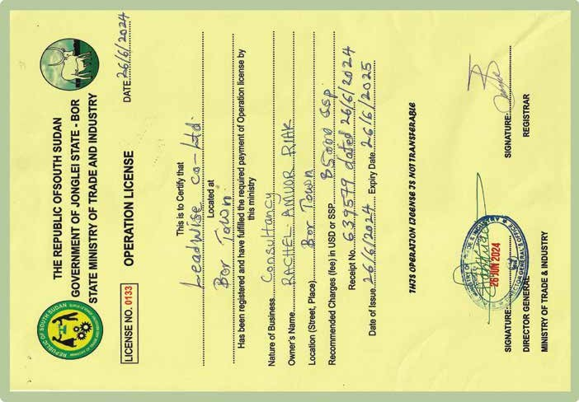

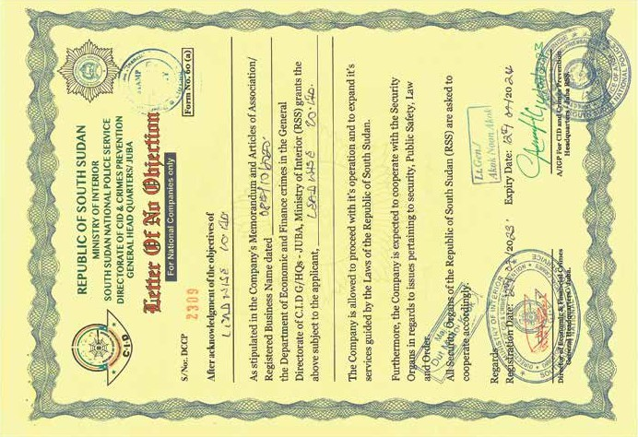

### LEADWISE 18

**At Leadwise we are committed to Corporate Social Responsibility (CSR) by giving 20% of our income towards Community Pevelopment. We are a responsible business that aspires to highest standards of Ethics and Professionalism.**

**20% CSR TOWARDS COMMUNITY DEVELOPMENT**

For Enquiries on Professional Training and Consultancy Services Please Contact Us On!

**LEADWISE** 19

**LEADWISE**

**+211 929 878 888**

[leadwise2012@gmail.com](mailto:leadwise2012@gmail.com) School of Law University of Juba

17

